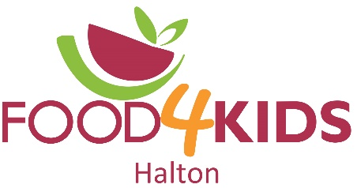
4391 Harvester Rd. Unit 3
Burlington, ON L7L 4X1
905-469-3113

Volunteer Application Form

Thank you for expressing interest in volunteer opportunities with Food4Kids Halton. Volunteers are our most valuable resource, and we would not exist without you! All eligible individuals that meet our minimum requirements are most welcomed and needed. Please note minimum age requirement is 16 years old unless supervised by an adult.

We collect the information below to ensure effective communication, volunteer recognition and safety. Any information given by you will remain confidential.

Date of Application (mm/dd/yy)

Contact Information
Name
Street Address
City, Province, PC
Cell Phone
Alternate Phone
Email Address

Availability
During which hours are you available for volunteer assignments? Check all that apply.

Availability | Monday | Tuesday | Wednesday | Thursday | Friday
- School Year | - AM | - AM | - AM | - AM | - AM
- Summer | - PM | - PM | - PM | - PM | - PM

Interests
Which areas are you interested in volunteering? Check all that apply.
- Packing food bags
- School deliveries
- Home deliveries
- Grocery shopping
- Packing support (Help restock the food, move crates and bins. Must be able to lift 25 lbs.)
- Food drive sorting/Inventory
- Special events (ie. Battle of the Chefs, Bottle Drives, Food Drives)
- Fundraising
- General help

How did you hear about Food4Kids?
- Social Media
- Brochure or Poster
- Word of Mouth (Family, Friend, Co-worker)
- Newspaper
- TV
- Other – please indicate: ____________________________________________________

Previous Volunteer Experience
Please list your past volunteer experience or any relevant training (i.e.: skills, certificates, licenses)

Person to Notify in Case of Emergency

Name: | Telephone: | Relationship:

Agreement and Signature

- I agree to keep all information confidential that I encounter while volunteering with Food4Kids Halton.
- I agree to provide Food4Kids Halton a copy of a current Vulnerable Sector Check before my first shift (if applicable).
- I understand that working in a warehouse environment includes some risk of physical injury. I hereby release Food4Kids Halton, its staff, board members and directors from any and all liability and/or responsibility for any accidents, injuries or illness that I may sustain while I am performing the duties of a volunteer.
- I understand that as a volunteer I am not covered under Workers Compensation.
- I affirm that I have read the above and that the information I have given above is true and complete.

Signature

Date

Thank you for your interest in volunteering with us. Please email completed form to the applicable Program Coordinator listed below:

Burlington/Oakville - jeannie@food4kidshalton.ca
Halton Hills - eva@food4kidshalton.ca
Milton - stacey@food4kidshalton.ca

For Office Use Only:

Date Application Received:

Date Contacted:

Start Date:

